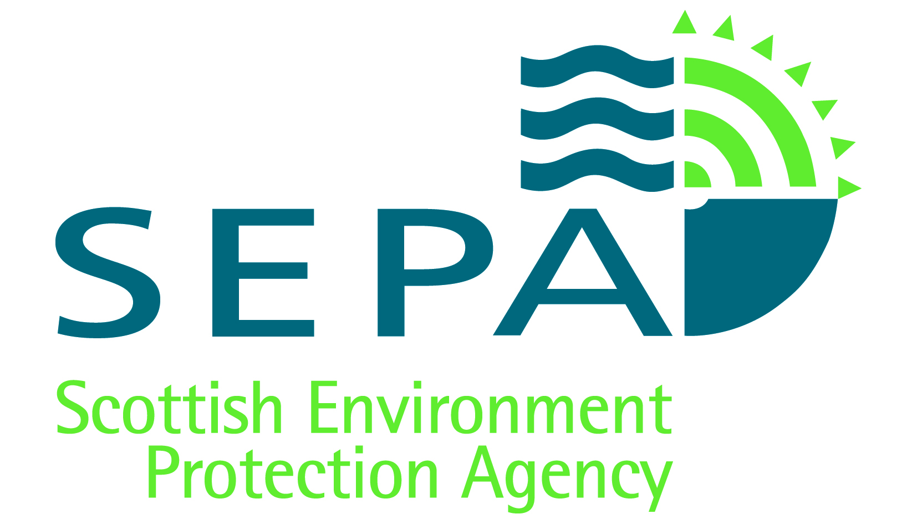

Pollution Prevention and Control (Scotland) Regulations 2012
Systematic Assessment of Resource Use and Efficiency

- The completion of this template is evidence that you have completed your systematic assessment of resource use and efficiency.

- Please note that once submitted to SEPA this template will be placed on the public register unless you apply to have it, or parts of it, excluded from the register on the grounds of commercial confidentiality.

Introduction

As a PPC Permit operator you are required to submit a systematic assessment of raw material, water and energy use and waste management, at intervals specified in your permit. This template has been produced to assist you with that assessment. It allows you to:

- record annual data;
- identify opportunities to optimise the use of raw materials, water and energy in your process and manage waste production;
- assess the viability of those options;
- provide timelines for their implementation.

In addition to reducing your impact on the environment, these assessments should bring cost advantages and improve competitiveness. We also aim to simplify data collection and reduce duplication. If energy data has been collected for other purposes (e.g. The Energy Savings Opportunities Scheme - ESOS) then that data may be used for this report - depending on the scope of the requirement.

This template covers a 4 year reporting period. At the end of the first reporting period you will identify improvement opportunities. For each subsequent 4 yearly submission you will review progress of those improvement opportunities and repeat the process of recording data and identifying future improvements.
What you should do now:

Complete Section A on an annual basis. You should start your data entry in the year corresponding to where you are in your reporting cycle in accordance with your permit e.g.

- If this is a new permit you should start at Year 1.
- For existing permits you should enter data into the column that corresponds to the year you are at in the systematic assessment cycle e.g.
  - If you are due to submit a systematic assessment in 2016 you should complete Year 4. (The data for Years 1-3 will already have been submitted to SEPA as part of your annual returns and should be left blank.)

Date systematic assessment is due | Column to start data entry in 2016 | Action required
2016 | Year 4 | Data entry and SA due
2017 | Year 3 | Data entry
2018 | Year 2 | Data entry
2019 | Year 1 | Data entry

- If your reporting period is different to the 4 year period speak to your SEPA officer.

During the 4 year reporting period you should monitor the progress of your identified opportunities on an ongoing basis.

When your 4 yearly assessment is due, complete Section B and submit the entire template, by the date specified in your permit. By doing this you can demonstrate that you are meeting the requirements of the PPC Regulations.

Please contact your local office should you need assistance or wish to discuss any aspect of this template. You should retain a copy of the completed template for your records.

Installation Details
Permit Number:
Operator:
Name of Installation:

SECTION A |  | Data  reporting
 | Part 1 | Raw material and waste data
 |  | The reporting of data should mirror the requirements identified in your PPC permit (as a minimum).
Using the relevant guidance
You should refer to the associated Supporting Guidance for the Systematic Assessment of Resource Use and Efficiency.
 | Table 1: Raw material and waste data
Raw Materials  (as identified in permit)  *Tonnes, Kgs, Litres, m³ |  | DATES (1st – 4th years)
 |  | Jan - Dec  [Year 1 Date] |  | [Year 2 Date] |  | [Year 3 Date] | [Year 4 Date]
Ethanol

Etc.
**Secondary raw materials (i.e. raw materials recovered from waste or production residues and is used as a substitute for virgin raw materials)
a) From on-site sources:
b) From off-site sources:

 | Table 1: Raw material and waste data - Continued
*** State your reference measure for annual production e.g. number of widgets, Gigawatt output, tonnes of waste treated or disposed.
 |  | Jan - Dec  [Year 1 Date] |  | [Year 2 Date] |  | [Year 3 Date] |  | [Year 4 Date]
Annual production figure (as gross tonnage)
Raw Material used per annual production
Reason for year on year variance |  | Record for each year the reason(s) for variance:  N.B When starting a new 4 year period, remember that the 1st year’s comparison is with Year 4 of the previous assessment period.
Waste and Material Losses (*Tonnes)
Production residues used off-site as a raw material

Amount of waste recycled off-site (Total)
Amount of waste disposed off-site ( i.e. landfill, incineration etc)
Reason for year on year variance |  | Record for each year the reason(s) for variance:  N.B When starting a new 4 year period, remember that the 1st year’s comparison is with Year 4 of the previous assessment period.

* Or unit specified in your permit.
** Data identifying the quantity of closed loop recycling is not required here but you should note where you have closed loop recycling in the relevant sections that follow.
*** Where the reference measure cannot be easily determined, then this should be agreed with SEPA.

 | Part 2 | Water sources
Identify all sources of water, how much you use and how much water is disposed of and where to.

N.B If figures are estimated rather than measured please indicate this with an (E).

 | Table 2: Water sources
Water Source  *m³ or Litres |  | DATES (1st – 4th years)
 |  | Jan - Dec  [Year 1 Date] | [Year 2 Date] |  | [Year 3 Date] | [Year 4 Date]
Mains supply water

Abstraction (surface water)

Abstraction (bore hole)

Collected Rainwater

Other
e.g.
Seawater (firewater)

Industrial (produced from off-shore)

Potable water (from desalters on site)
Total Water Used

Table 2: Water Sources - Continued
 | Jan - Dec  [Year 1 Date] |  | [Year 2 Date] | [Year 3 Date] |  | [Year 4 Date]
Does this include non PPC activities such as offices, canteen etc?
** State your reference measure for annual production e.g. number of widgets, Gigawatt output, tonnes of waste treated or disposed.
Annual production figure (as gross tonnage)

Water used per annual production

Reason for year on year variance | Record for each year the reason(s) for variance:  N.B When starting a new 4 year period, remember that the 1st year’s comparison is with Year 4 of the previous assessment period.
Water losses
Total Water disposed
Where is water / effluent / treated effluent lost or disposed to: E.g. sewer; ***water environment; evaporation; product; wastes; recycled etc.

* Or unit specified in your permit.
** Where the reference measure cannot be easily determined, then this should be agreed with SEPA.
*** The water environment means all surface water, ground water and wetlands. See Appendix 1.

 | Part 3 | Energy consumption
If figures are estimated rather than measured please indicate this with an (E).

N.B Energy producing activities should refer to the associated Guidance about raw materials, waste, water and energy, which provides clarification about the purpose of this table.

 | Table 3: Energy Consumption
*Energy  Used on site  kWh or MWh |  | DATES (1st – 4th years)
 |  | Jan - Dec  [Year 1 Date] | [Year 2 Date] | [Year 3 Date] | [Year 4 Date]
Electricity (public supply)

Electricity (other supply)

Imported heat (steam, hot water)

Gas

Oil
Coal

**Other
e.g. Waste or materials, surplus heat used on site
Total energy used
Table 3: Energy Consumption - Continued
 | Jan - Dec  [Year 1 Date] | [Year 2 Date] |  | [Year 3 Date] |  | [Year 4 Date]
Does this include non PPC activities such as offices, canteen etc?
***State your reference measure for annual production e.g. number of widgets, Gigawatt output, tonnes of waste treated or disposed.
Annual production figure (as gross tonnage)
Energy used per annual production
Reason for year on year variance | Record for each year the reason(s) for variance:  N.B When starting a new 4 year period, remember to compare the 1st year with the last year of the previous assessment period.
Surplus Power (sent off-site)
Surplus heat (including steam) provided to 3rd party or heat network
Surplus electricity provided to 3rd party or to the National Grid (MWh)

* Or unit specified in your permit.
** Specify additional fuels, including recovery of energy from wastes or other materials.
*** Where the reference measure cannot be easily determined, then this should be agreed with SEPA.

SECTION B |  | Systematic assessment of raw material, water, energy and fuel consumption
Undertaking a systematic assessment

Completing the questions in each of the following sections will provide you with the information you need to manage your use of raw materials, water and energy more effectively. It will enable you to:

- Understand how much you use
- Understand where and why there are losses
- Identify opportunities to improve efficiencies
- Review outcome following implementation of opportunities
- Consider, where appropriate, next steps to ensure continuous improvement

Using the relevant guidance

Each of the following parts comprises a number of high level questions. Before answering each question you should refer to the more detailed guidance on the various aspects we expect you to consider:

- For Parts 4 – Part 9 you should refer to the associated Supporting Guidance for the Systematic Assessment of Resource Use and Efficiency.

- For Part 7, if you are a SME, then you may find the following guidance useful:
  - The DECC Guide to Energy Efficiency

In addition, you should also refer to any sector guidance and Best Available Techniques (BAT) Reference documents (BREFs) that apply to your installation. These documents can be found on SEPA’s website at:
www.sepa.org.uk/regulations/pollution-prevention-and-control/guidance/

 | Part 4 | General Management
 | Table 4:
 | We expect you to provide a short justification for your response to each question. |  |  | YES | NO | N/A
1 | Have you read the sections relating to resource efficiency in both the sector guidance and BREF documents that are relevant to your activity?  Which sector guidance and BREF documents are you using and why?
2 | Are there any resource efficiency benchmarks available and applicable e.g. BREF or sector specific?  Please record them here and also provide an outline of your plans to meet them in the box at the end of this table.
3 | Have you undertaken a review of technologies and technique advances?  If applicable advances have been made, briefly summarise in the box at the end of this table how and by when you plan to implement these, including what impact this will have on the efficient use of resources?  Where you are not planning to implement these identified advances, provide here a brief explanation about why they are not suitable for your process(es):
4 | Are your Staff aware of and engaged in process efficiency?  If YES, provide examples:  If NO, please explain why:
5 | Do you monitor / assess basic housekeeping measures to minimise your use of raw materials?  Briefly describe how you do this:
6 | Having considered the above questions, please record here any current plans or new opportunities that will support your drive to improve resource efficiency. These will be considered in Part 8 of this template:

 | Part 5 | Raw materials and waste management (excluding water)
 | Table 5: Managing Raw Materials and Waste
 | We expect you to provide a short justification for your response to each question. |  | YES | NO | N/A
1 | Have you reviewed the selection of your raw materials to reduce your overall environmental impact?  If YES, provide a brief summary:  If NO, please justify why not:
2 | Are you tracking losses of materials and generation of waste or defective materials?  If YES, please outline how:  If NO, please justify why not:
3 | To avoid, reduce or reuse materials, have you implemented any in-house or any formal process efficiency programmes such as LEAN or Six Sigma etc?  Please provide details:
4 | Do you have a process to review the substitution of any of the virgin materials you use / purchase with secondary raw materials or production residues?  If YES, record any opportunities that you have identified in the box at the end of this table.  If NO, will you look at opportunities to use secondary raw materials or production residues?

 | Table 5: Managing Raw Materials and Waste - Continued
5 | Describe how you are managing your waste in line with the waste hierarchy.
6 | Having considered the above questions, please record here any current plans or new opportunities to improve resource efficiency and / or waste management. These will be considered in Part 8 of this template:

 | Part 6 | Water
 | Table 6: Managing Water Use
 | We expect you to provide a short justification for your response to each question. |  |  | YES |  | NO | N/A
1 | Can the use of water be avoided / eliminated?  If YES, please provide in the box at the end of the table any opportunities that you have identified.  If NO, please justify why not:
2 | Can you reduce water use?  If YES, please provide in the box at the end of the table any opportunities that you have identified.  If NO, please justify why not:
3 | Can you reuse and / or recycle the water used within your process?  If YES, please provide in the box at the end of the table any opportunities that you have identified.  If NO, please justify why not:
4 | Where water is disposed to sewer, the water environment, or other, could this be reused / re-circulated?  If YES, please provide in the box at the end of the table any opportunities that you have identified.  If NO, please justify why not:
5 | Having considered the above questions, please explain what water is used for and record here any current plans or new opportunities to improve water efficiency. These will be considered in Part 8 of this template:

 | Part 7 | Energy
 | Table 7: Managing Energy Use
 | We expect you to provide a short justification for your response to each question. |  |  | YES |  | NO | N/A
1 | Is your activity covered by a climate change agreement or are you a participant in the EU Emissions Trading System or both?  If YES, provide details and then answer questions 2 and 3 below.  If NO, answer questions 2, 3 and 4 below.
 | Basic energy requirements - This section applies to all PPC activities and relates to the processes and process buildings associated with the PPC permit (but excluding any office and accommodation buildings).
2 | Can you demonstrate that your process is operating in line with good practice in respect of the following areas?  a) Monitoring and understanding your energy usage  If YES, please provide a brief summary:  If NO please justify why not:  b) Energy management techniques  If YES, please provide a brief summary:  If NO please justify why not:  c) Operating and maintenance procedures  If YES, please provide a brief summary:  If NO please justify why not:  d) Basic physical measures for heating and cooling losses:  If YES, please provide a brief summary:  If NO please justify why not:  e) Building services  If YES, please provide a brief summary:  If NO please justify why not:
3 | Can you optimise your energy consumption using the Energy Efficiency Checklists located in Appendix 1 of the supporting guidance?  If YES, please provide in the box at the end of the table any opportunities that you have identified.  If NO, please justify why not:
 | Table 7: Managing Energy Use - Continued
 | Further energy efficiency techniques
 | We expect you to provide a short justification for your response to each question. |  |  | YES |  | NO | N/A
4 | Describe here proposals for further, process related energy efficiency measures, which go beyond the low-cost basic physical measures described above (refer to the supporting guidance for detail):
5 | Having considered the above questions, please record here any current plans or new opportunities to improve energy efficiency. These will be considered in Part 8 of this template:

 | Part 8 | Identifying opportunities as part of your assessment
Are you confident that the techniques you are using are not wasting any resource and costing you money? Are you using the best techniques available to you? Even if you have ticked “NO” to any of the boxes above there is likely to be an opportunity for you to use resources and manage your waste more efficiently.

Carry forward, to the tables below, each of the improvement opportunities identified in Parts 4 – 7 of this template:

- Copy the table to record additional opportunities, as required.

- Complete the various sections in accordance with the supporting guidance.

Opportunity Number __
Reference the relevant Part and Question
Outline the opportunity with your current system:

What improvement options are available / have been considered?

Which if any are you implementing (provide justification for your decision including cost vs environmental benefit):

Implementation timeline:

Review of progress:
I.e. has it been implemented – when? If not, why not?

 | Part 9 |  | Reviewing progress and next steps
Step (i)

Briefly summarise the focus of the work undertaken in the last 4 years. In the second half of this table summarise the improvements implemented and the benefits achieved as a result. In addition, any improvement opportunities that failed to progress should be recorded here.

Brief summary of work undertaken during the 4 year period:
Summaries for successful and unsuccessful projects:
Opportunity 1  Title |  | Summary of progress
Opportunity 2  Title |  | Summary of progress
Opportunity 3  Title |  | Summary of progress
Opportunity 4  Title |  | Summary of progress

 | Part 9 |  |  |  |  | Reviewing progress and next steps - Continued
Step (ii)

To ensure the continuity of implementation or to justify why a different direction or course of action is being taken at the start of the new 4 year review period, please record below those opportunities (either ongoing or pending) that will be carried forward.
Opportunity W  Title |  |  | Summary of progress
Opportunity X  Title |  |  | Summary of progress
Opportunity Y  Title |  |  | Summary of progress
Opportunity Z  Title |  |  | Summary of progress
Step (iii)

Once you have completed your systematic assessment send it to SEPA by the timeline indicated in your permit. Your site officer will review your report and discuss your progress with you.

Contact details
Date resource efficiency assessment completed:
Contact name:
No Signature required

Appendix 1: Water environment

The definition of water environment is stated in Regulation 3 of the Water Environment and Water Services (Scotland) Act 2003:

3 The water environment: definitions

(2) “The water environment” means all surface water, groundwater and wetlands.

(3) “Surface water” means inland water (other than groundwater), transitional water and coastal water.

(4) “Groundwater” means water which is below the surface of the ground in the saturation zone and in direct contact with the ground or subsoil.

(5) “Wetland” means an area of ground the ecological, chemical and hydrological characteristics of which are attributable to frequent inundation or saturation by water and which is directly dependent, with regard to its water needs, on a body of groundwater or a body of surface water.

(6) “Inland water” means—

(a) all standing or flowing water on the surface of the land (other than transitional water), and

(b) all groundwater,

within the landward limits of coastal water.

https://www.gov.uk/government/uploads/system/uploads/attachment_data/file/417410/DECC_advice_guide.pdf

