

Position Statement on Development Protected by Formal Flood Protection Schemes
July 2024

This document will be reviewed approximately six months from the date of publication. Any comments or suggestions on the content should be emailed to elaine.fotheringham@sepa.org.uk and will be considered as part of the review.

Position Statement on Development Protected by Formal Flood Protection Schemes

Purpose
This information note outlines our position relating to proposed development on land protected by a formal flood protection scheme. The position is our interpretation of National Planning Framework 4 (NPF4) and our duties under the Flood Risk Management (Scotland) Act 2009.

Reducing flood risk across Scotland
Flood protection schemes play a critical role in reducing flood risk. For this reason, they are identified in the suite of actions to reduce flood risk in the fourteen flood risk management plans and associated local flood risk management plans covering Scotland. The actions associated with flood protection schemes help to reduce flood risk to existing communities and businesses and reduce the associated damages caused by flooding.

National Planning Framework 4 and flood protection schemes
The land use planning system has a pivotal role to play in ensuring that Scotland becomes more resilient to flooding. This is achieved by avoiding new development in flood risk areas to ensure there is an overall reduction in the vulnerability of development to flooding. As well as avoiding flood risk, development already at risk can be made more resilient when adaptation, redevelopment or regeneration is planned. As part of the overall picture of flood resilience, flood protection schemes can reduce flood risk but cannot eliminate it entirely (Flood protection schemes - assessment of economic, environmental and social impacts: guidance - gov.scot (www.gov.scot)). Their primary purpose is to protect existing development from flood risk rather than to facilitate new development. For this reason, caution and careful consideration is required when planning and promoting any new or re-development in areas where protection from a scheme is being relied upon to ensure that flood risk can be avoided.
NPF4 defines ‘at risk of flooding’ as land or built form with an annual probability of being flooded of greater than 0.5% which must include an appropriate allowance for future climate change. The calculated risk of flooding can take account of any existing, formal flood protection schemes in determining the flood risk to the site.
Flood protection schemes are designed based on what is feasible to achieve the greatest benefit for a community. The protection they offer once they have been in place for some time, or will offer in future, is less certain. This is due to the changing climate, changes to coastlines and river channels, the effects of the scheme’s design life, its condition over time and the possibility of a failure of some kind. This means that most schemes provide less protection than the standard that is required for new development. New developments should be safe for the longer term, by avoiding the risk of flooding including the effects of climate change.
As set out in NPF4, it is possible to take account of the protection offered by an existing formal flood protection scheme or one under construction, to reassess the area identified as being at risk of flooding. That means considering in detail a range of scenarios. That detailed consideration may be able to identify land where – having taken account of the scheme and its residual risk – the overall risk is low enough to be suitable for new development. This reassessment should be carried out before any development is considered in defended areas, other than for the types of development that can be supported in flood risk areas.
SEPA’s flood maps do not show what happens at a flood protection scheme during flood events larger than the scheme is designed for, and do not include information on operational failure, breach or condition. In some places the SEPA flood maps are based on more detailed modelling than the standard approaches applied nationally, and so may contain some information on the effects of defences. But, full consideration of residual risk is not included, and the model scale is still strategic, so they can only provide a starting point.

When evidence is not available to take account of a flood scheme
In many places, given the challenges presented by climate change, an existing flood protection scheme on its own will not provide a high enough level of protection to support new development in the defended area.
In those cases, or where evidence accounting for a scheme is not available, areas reliant on flood protection schemes are at risk of flooding for planning purposes. Development proposals that will be supported in flood risk areas should be limited to those set out in policy 22 of NPF4 and all relevant criteria included in the policy should be met.
These developments can be supported regardless of the standard of protection offered by the existing flood scheme. SEPA’s Standing Advice has more guidance on meeting the requirements of the policy and land use vulnerability classifications are defined in the Land Use Vulnerability Guidance.

How to take account of a flood protection scheme
Formal flood protection schemes are designed, managed and maintained by local authorities in their role as the flood risk management authority. Local authorities are therefore best placed to understand what would happen in the event of a flood protection scheme experiencing a larger flood event than it is designed to protect from, or from longer term changes to the scheme. Detailed understanding of the effects is complex to achieve and so investigations to provide the necessary evidence on this are likely to be focused on locations where there is plan-led support for locating new development in areas benefitting from protection, and the place is a strategic priority for maintaining a permanent high level of protection from flooding in most current and future climate scenarios.
To support new development on land protected by a flood scheme, the evidence provided must take the whole flood scheme into account to redefine the area that is at risk of flooding for planning purposes and must include consideration of how the scheme operates. Land to be developed must be shown to be free of flood risk in the 0.5% annual probability scenario including the required allowance for climate change. The appropriate allowance for climate change for land use planning is set out in SEPA’s guidance on climate change allowances. This is the allowance that should be applied to any detailed assessment to calculate the risk of flooding.
Any study or assessment undertaken to provide evidence for development will generally be for a larger scale than would be provided for individual site flood risk assessments, to consider the whole scheme and all the land defended by it. Such studies would have to be carried out, supported or endorsed by the local authority responsible for the maintenance and operation of the scheme. For newer schemes, information from the scheme design stages may be applicable, though additional information will be required to confirm the design is as built, and that the full range of required hydrological, operation and condition scenarios are included.
The scope of the assessment is for the authority responsible for the safety of the scheme to determine. SEPA’s recommendation is that the following should be considered in detail:
- The risk when larger floods happen than the flood protection scheme is designed to protect from, including the required climate change scenarios.
- The probability and consequences associated with operational failure of the scheme.
- The probability and consequences of a breach occurring, particularly as the condition of the scheme may change over time.
Links should be made with any adaptation plans that have been produced on how schemes or communities will be adapted in future to cope with increasing flood risk due to climate change. Conversely, studies to take account of flood protection schemes will be valuable evidence to inform adaptation planning.
The strategic flood risk assessment carried out as part of the Local Development Plan process is the best place to record the understanding of flood defences where evidence has been established.

Glossary

Formal Flood Protection Scheme
Formal flood protection schemes are managed by an appropriate public body with appropriate responsibility for long-term maintenance. It is limited to schemes promoted through relevant legislation (i.e., Flood Prevention (Scotland) Act 1961 (as amended in 1997), the Flood Risk Management (Scotland) Act 2009 (Section 56 and 60) or Coast Protection Act 1949).
Flood protection schemes cover all measures designed and implemented to reduce exposure of receptors to flood risk and include direct defences (walls and embankments), indirect defences (flood storage schemes), and other engineering works such as culverts, diversions and channel/floodplain engineering.

Informal flood defences
Informal flood defences are proposals that have not been promoted through relevant legislation.
Any protection offered by informal flood defences would not be taken into account when considering development behind or benefitting from them, to be considered as if the defence does not exist. The structural condition, design standard and long-term maintenance arrangements are not assured, so they therefore pose a significant level of risk to any proposed development behind or benefitting from them.

Most vulnerable uses
Developments that introduce most vulnerable uses need very careful consideration. The consequence of flooding is much higher, and this must be considered in detail against the residual risk of the scheme, the lifespan of the scheme and the lifespan and nature of the development.

Residual flood risk
The risks that remain after actions have been taken to manage or reduce flooding.

Summary
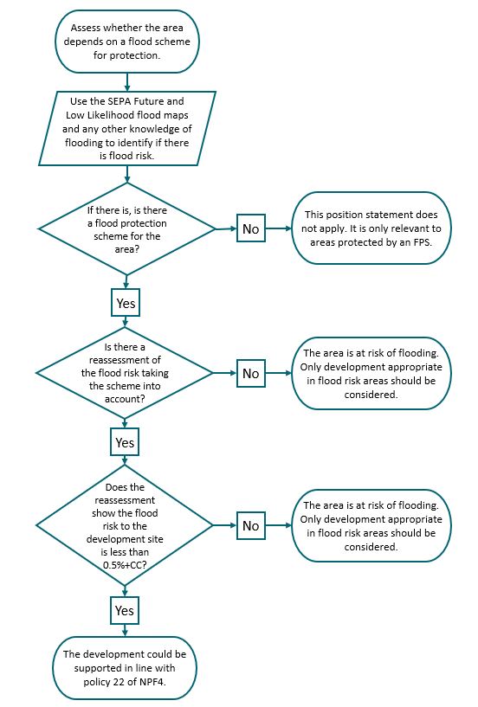

If you would like this document in an accessible format, such as large print, audio recording or braille, please contact SEPA by emailing equalities@sepa.org.uk

